

BINARY TO DECIMAL CONVERTER (0-9)

Using ic’s and logic gates

Project by:

Meerab Hanif (01-134251-041)

Iqra Agha (01-134251-026)

Tehreem Fatima (01-134251-091)

Submitted to:

Sir Umar Hayat (Applied Physics Lab)

# INTRODUCTION

A binary to decimal system converter is a tool or a system that transforms numbers expressed in the binary number system (0’s and 1’s) to their equivalent values in decimal (which uses digits from 1 to 9). The binary system is fundamental language of computers and digital electronics, where each digit represents a power of 2. This conversion is important because while machines operate using binary logic humans use the decimal system in everyday life. Therefore, a binary to decimal converter helps bridge the gap between digital systems and human understanding, making it easier to interpret binary outputs or design systems that display information in a more familiar format. These converters can be implemented in software through programming or in hardware using digital logic circuits and decoder IC s. This project, titled *Binary to Decimal converter* is a hardware-based converter which aims to demonstrate the fundamental concept of number system conversion in digital electronics. The main objective is to convert a 4-bit binary input into its decimal equivalent using a simple manual hardware circuit. This project helps in learning basic components like BCD decoders, and practically applying theoretical concepts using breadboard and ICs. This project bridges basic compute logic with practical physics and electronics knowledge.

# OBJECTIVE

To design and demonstrate a system that converts a binary number input into its corresponding decimal number output using logical methods or electronic components.

# MATERIAL REQUIRED

* 4 Dip switches (for input) -------------------------------------------------(4)
* 7447- BCD to 7-segment decoder IC------------------------------------(1)
* 7-segment display (common anode) -------------------------------------(1)
* Resistors 220Ω-Current limiting for each display segment------------(7)
* Resistors 10kΩ-Pull down resistors for dip switches -------------------(4)
* Breadboard (400 tie-points-------------------------------------------------(1)
* Jumper wires ---------------------------------------------------------------(7+)
* Power supply (5V battery using 3 AA batteries) ------------------------(1)

# PROJECT METHODOLOGY

Here’s how the methodology was implemented:

* We start by placing dip switches, BCD to 7-segment decoder IC and 7-segemnt display onto the breadboard.
* The switch has total of eight pins (1-8).
* We start by connecting pins 1 through 4 all to power, then we connect pins 5 through 8 to the ground using 1ok resistor.
* The 7447 decoders have total of 16 pins (1-16).
* Connect pin 3,4,5 and 16 to power and pin 8 to ground.
* Total pins on 7-segment display are 10.
* We can see that our common anode pins are 3 and 8, so we will connect these two pins to power.

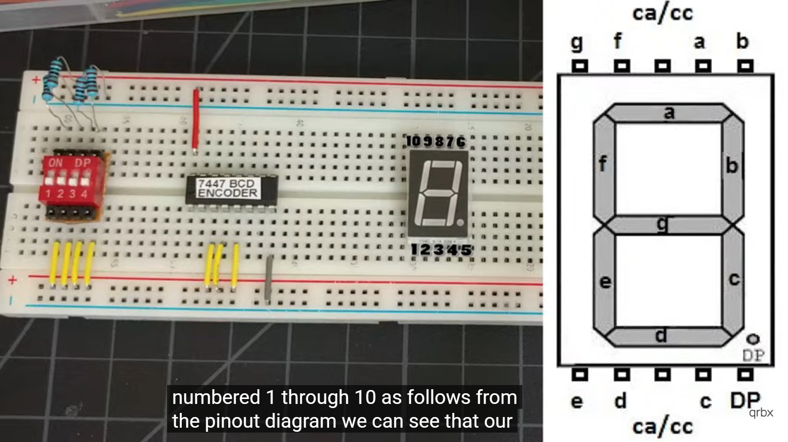

* Using jumper wire connect the output of the switch to the 7447 decoders, start by least significant bit which is 5 to pin 7 of the decoders.
* Pin 6 will connect to pin 1 of the decoder, pin 7 to pin 2, pin 8 to pin 6.
* Connect 7447 decoder to the 7-segment display, note that these connections will have their own 220-ohm current limiting resistors.
* Start by connecting pin 15 of decoder to pin 9 of 7-segment display, pin 14 to pin 10, pin 13 to pin 7, pin 12 to pin 6, pin 11 to pin 4, pin 10 to pin 2 and pin 9 to pin 1.
* Join power and ground together and plug in your power supply.

# CIRCUIT DIAGRAM

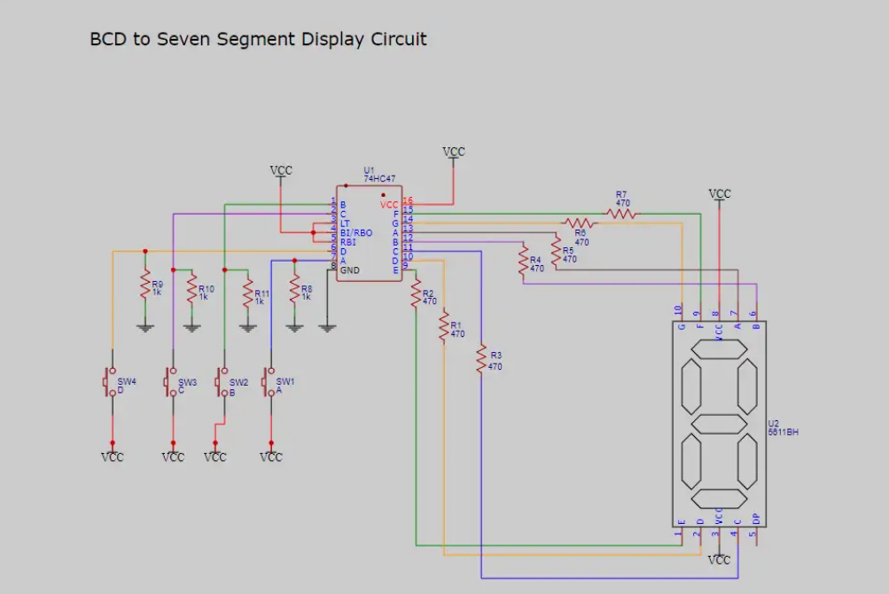

# TESTING AND VALIDATION

The circuit was tested for all 4-bit binary combinations from 0000 (0 in decimal) to 1001 (9 in decimal). The following strategies were used for validation:

* Each input was manually applied using the dip switches, and the output on the 7-segment display was observed.
* The decimal display was verified using known binary equivalents.
* Invalid BCD inputs (1010 to 1111) were also tested to observe their behavior and understand the limitation of the IC 7447, which only supports 0-9.
* The system consistently performed accurate conversions for valid BCD inputs, proving the logic and functionality of the circuit.

|  |  |
| --- | --- |
| Input (Binary) | Output (Decimal) |
| 0000 | 0 |
| 0001 | 1 |
| 0101 | 10 |
| 1111 | 15 (may not be visible on 7-segment display) |

# GIT HUB LINK

Project Repository: 🔗 [Binary Beam on GitHub](https://github.com/Iqra039/Binary-Beam-)

# CONCLUSION

The projects successfully demonstrated a manual binary to decimal converter using basic electronic components. It helped in understanding the working of number systems and provided hands-on experience with hardware design, logic gates (via ICs), and 7-segment display control.

**Challenges faced included**:

* Identifying compatible components (e.g., matching IC 7447 with a common anode display).
* Ensuring stable input signals without switch bounce or noise.
* Limited output range due to the BCD decoder’s restriction to values 0-9.

**Future Enhancement could include:**

* Using am Arduino or microcontroller to allow conversion of more than 4-bit binary values.
* Adding an LCD display for wider output range.
* Implementing binary to hexadecimal or binary to ASCII converters for advanced applications.

# APPLICATION

* Used in microprocessors and digital systems.
* Foundational in designing calculators, digital clocks, and computers.
* Helpful in understanding how digital data is processed in electronics.

# REFERENCES

* Data Sheet- IC 7447 BCD to 7-segment Decoder. Texas instruments
* Digital Logic and Number System-Punjab Textbook board (physics)
* <https://www.electronics-tutorials.ws/> - Binary and 7-segment Display Tutorials.